1. A picture containing icon

   Description automatically generated  
     
   
2. Diagram

   Description automatically generatedWe already learnt that Apache Kafka organizes msgs in **Topic**.  
   and the **Broker** creates a **log file** (c:/tmp/kakfa-logs-0/000000000.log) under **Log Dir** (c:/tmp/kakfa-logs-0) for each Topic to store these msgs.   
   Jatin 🡺 Topic: Logical, File: Physical.
3. However, a log file is **partitioned, replicated, and segmented** (See the above Diagram)
4. In this lecture, I will not only explain but will also show you the Kafka **Log** **File Organization**. This lecture is going to be a working section.
5. Let’s start with a high-level concept of Topic.

`

1. A topic is a logical name to group your msgs.  
   Like in DB, you create Table to store your records.  
   So, in Kafka, you should create Topic to store your msgs.
2. Diagram

   Description automatically generated
3. Let’s create a topic to see things in action.
4. Diagram

   Description automatically generatedActually, we want to understand how a topic (partition) is organized at the broker level.  
   We will create a topic and will investigate these Data Dir (kafka-log-0, kafka-log-1, kafka-log-2) to see how a topic is held at the physical level.
5. Let’s create Topic.  
    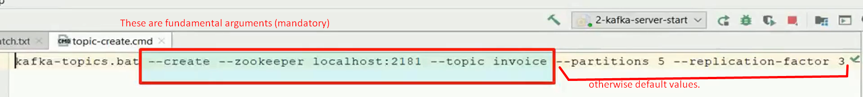  
   The above **topic-create.cmd** file is under scripts of the project.  
   
6. Let’s talk about Topic Partition.



1. In Kafka, a Topic may store millions of msgs.
2. Hence, practically impossible to keep those msgs in a single file.
3. Topic partition is a mechanism to break a topic into smaller parts.
4. For Apache Kafka, **a partition is nothing but a physical Dir**.  
   Apache Kafka creates a separate Dir for each topic partition.  
   Actually, we created a topic with 5 partitions and 3 replicas whereas we have 3 nodes in Kafka Cluster.  
   So a partition say A will have 3 copies thus one copy on each node. So, each node will have a total of 5 partitions. You can do calculations.
5. Diagram

   Description automatically generated
6. Graphical user interface, application, PowerPoint

   Description automatically generated